Will Kelsey, Nick Krysko

Prof. Carpenter

Applied Programming Concepts

CURSE

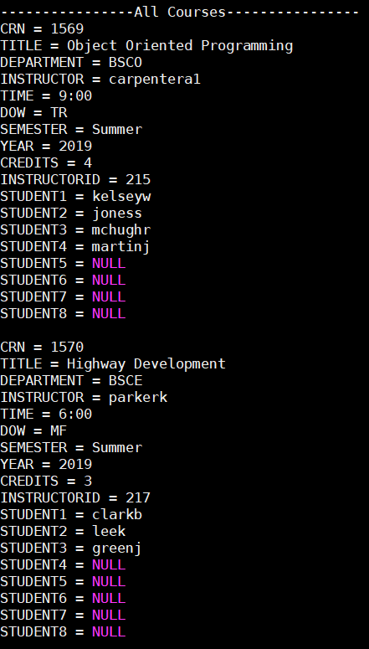

This is the Course User Registration Emulator or CURSE. Over the course of this semester, CURSE has grown from an idea to a fully-fledged system that simulates the user experience of the student, instructor, and administrator. With the goal of fixing the current flawed registration system that is implemented at Wentworth, the project was built. Several users have expressed problems with the registration system in production use at Wentworth. These issues span from courses being placed improperly to registration day struggles. CURSE is designed to simplify these processes and build a more robust registration system.

The basis for this system is an SQL database. SQL is a fully featured and very robust database language used in many industries. It is tried and true for building a solid software backbone. CURSE was not always built on SQL. Originally it was built in C++ using dynamically linked lists. These proved the functionality of building a registration system was possible. However, as the number of users, students, and courses grew, it became increasingly clear that it would not be the permanent solution. The difficulty of creating an efficient program with linked lists showed that some other backbone was needed. With the implementation of SQL for the backbone, it forced a full rewrite of the software. Now with the robustness of a database to back up the software, the limitations of linked lists were thrown out. This rewrite replaced nearly all functions and tasks with SQL queries. The increase in efficiency also came with the benefit of other capabilities added. SQL provided many tools that allowed cross refences of different database tables and provide more information for the user. This in turn simplifies the user interface and displays more useful information.

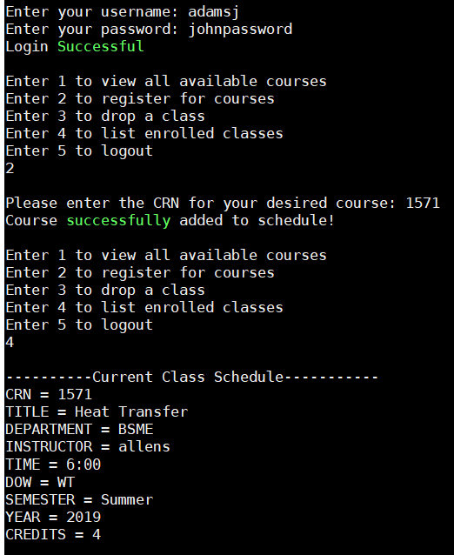 CURSE begins with a login prompt. It queries a username and password and provides the interface that suits the user. For instance, a student will log in and be greeted with a menu targeted towards students; they should not have the same abilities as the admin. The student can view all available courses, view their own course schedule, register for a course, and finally drop a course if needed. Likewise, an instructor should only be able to see the courses they are teaching and the students within. When an admin logs in, they have all the abilities of the student and instructor with the added capability of creating courses. The admin can also see more details about the course than the students or instructors.

By default, the program begins with a test case of several users and courses. This gives the ability to view what the program can do before fully implementing it in a given environment. This initial environment consists of a pre-filled database and is intended for testing purposes only.

CURSE is the beginning of a full registration program for education environments. Further development is needed before deployment can be considered. There are several caveats with a production environment that is not simulated here but must be included in the deployable version. It is not recommended as a replacement for Wentworth’s registration system yet but is well on its way to becoming a fully-fledged system.

